**VCC : Assignment No. 3**

* **By**

[**Mandar Bhalerao (M23CSA025)**](mailto:m23csa025@iitj.ac.in)

# Google Drive Link :

# **https://drive.google.com/drive/folders/16SEBr1mXfLErhmXOmsAwGlzrT4PiUhbp?usp=sharing**

# 

Github Link :

[git@github.com](mailto:git@github.com):m23csa025/VCC-Assignments.git

<https://github.com/m23csa025/VCC-Assignments/tree/VCC-Asgnmt--03>

# 

# **Create a Local VM and Auto-Scale It to GCP or Any Other Public Cloud When Resource Usage Exceeds 75%**

**Objective:**

Create a local VM and implement a mechanism to monitor resource usage. Configure it to auto-scale to a public cloud (e.g., GCP, AWS, or Azure) when resource usage exceeds 75%.

**Deliverables:**

1. Document Report:

Step-by-Step Instructions for Implementation:

Creation of a local VM (using VirtualBox, VMware, or similar).

Implementation of resource monitoring (using tools like Prometheus, Grafana, or a custom script).

Configuration of cloud auto-scaling policies and resource migration.

Deployment of a sample application to demonstrate the process.

2. Architecture Design:

Diagram illustrating the flow: local VM resource monitoring → scaling to cloud → deployment.

3. Link to Source Code Repo:

Repository containing monitoring scripts, deployment configurations, and application code.

4. Link to Recorded Video Demo: A video showing the setup, resource monitoring, and auto-scaling process in action, with a detailed voice-over.

## 

## **1. Introduction**

The process of creation of environment in Debian 12 based VM and autoscaling to GCP on CPU usage 75% are given below.

1. **Creation of Local VM**

* My Laptop Macbook M2
* Installation of UTM
* Installation of Debian 12
* Creation of New VM (vm3 - 4 GB, 40 GB)

1. **Implementation of resource monitoring tools**

* Open terminal
* **nano monitor.sh** (monitoring tool for monitoring CPU and Memory Usage**)**

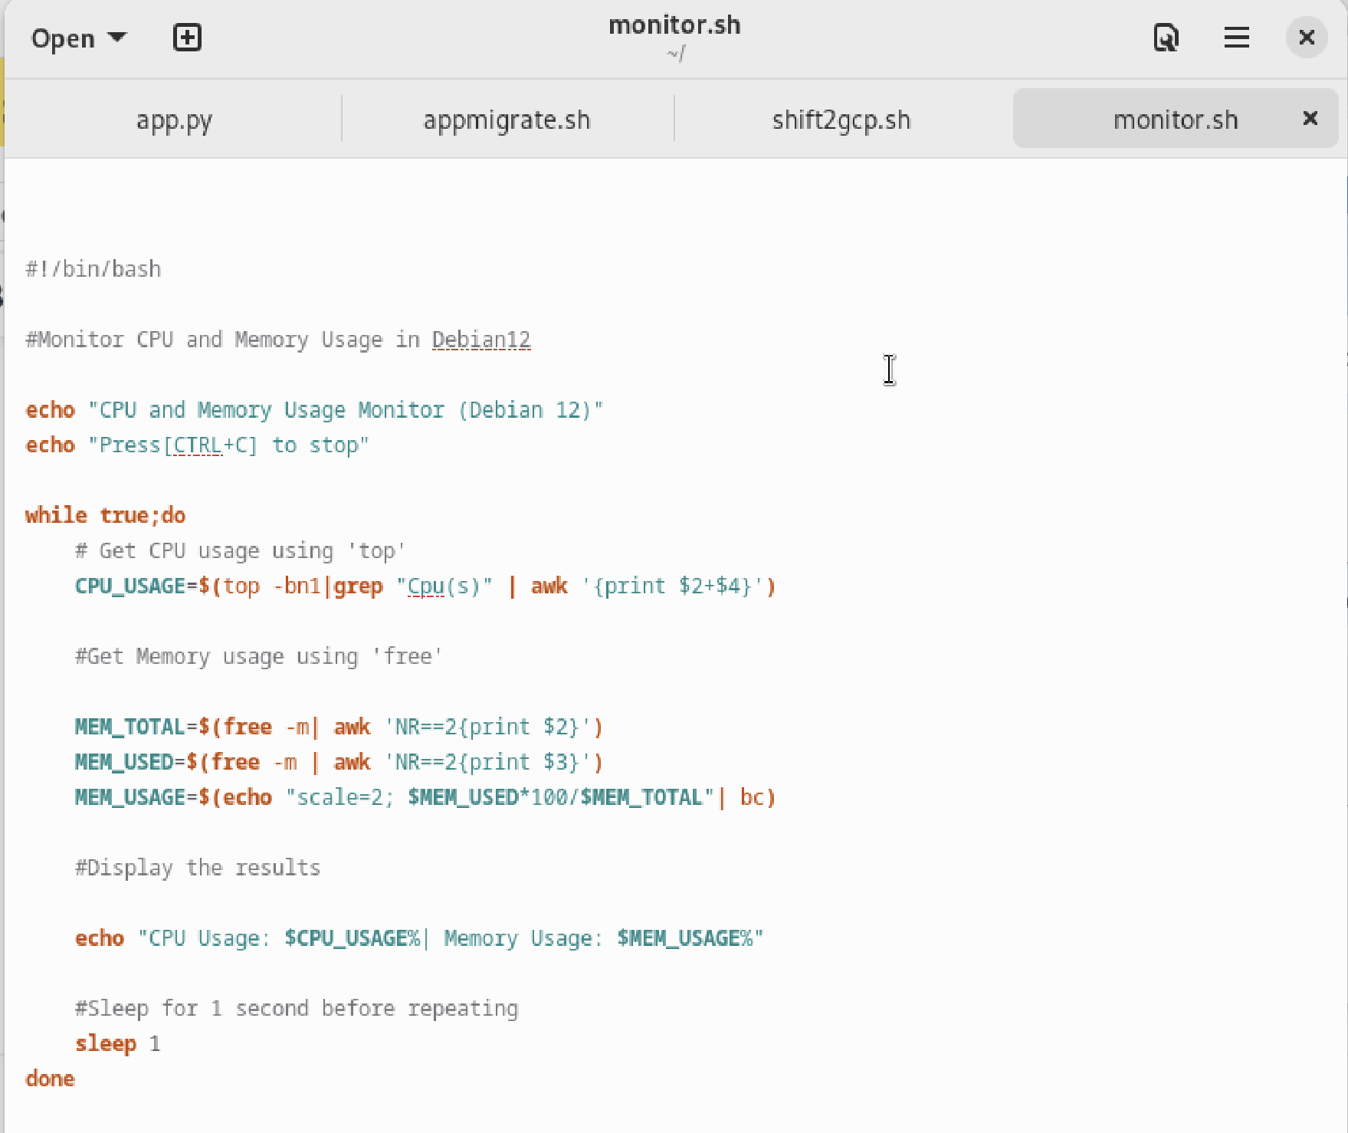

**- Install stress app to load cpu**

**-** stress –cpu 4 –timeout 60s

1. **Configuration of GCP migration policies & resource migration**

* **Current status of VMs in the GCP accts**

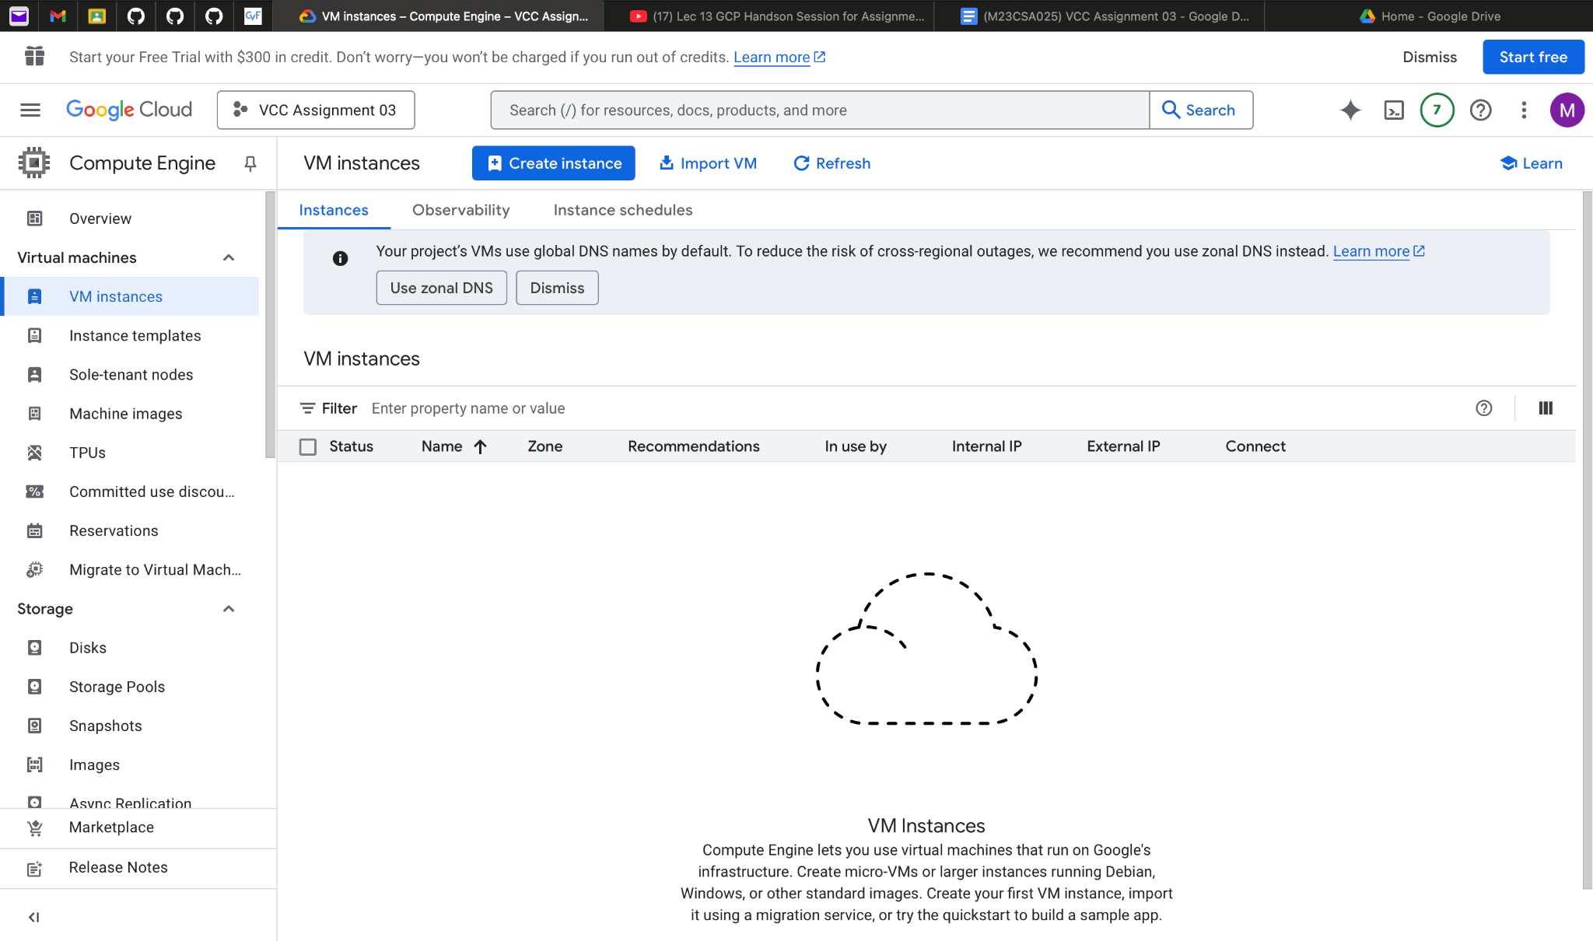

**- nano shift2gcp.sh** (code for autoscaling to GCP on cpu load reaching 75% threshold)

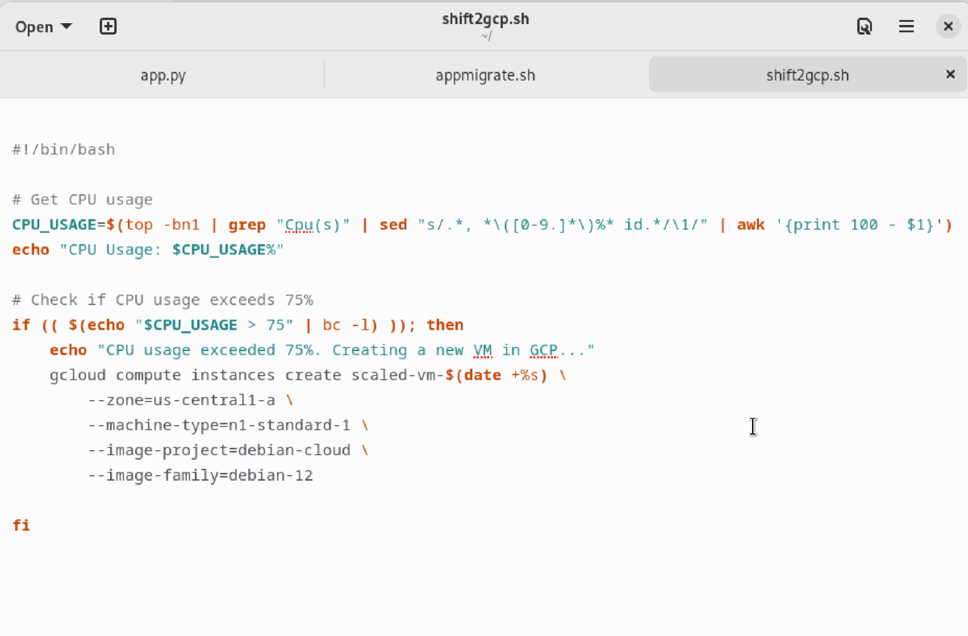

**- Activation of service acct on GCP and Creation of Key**

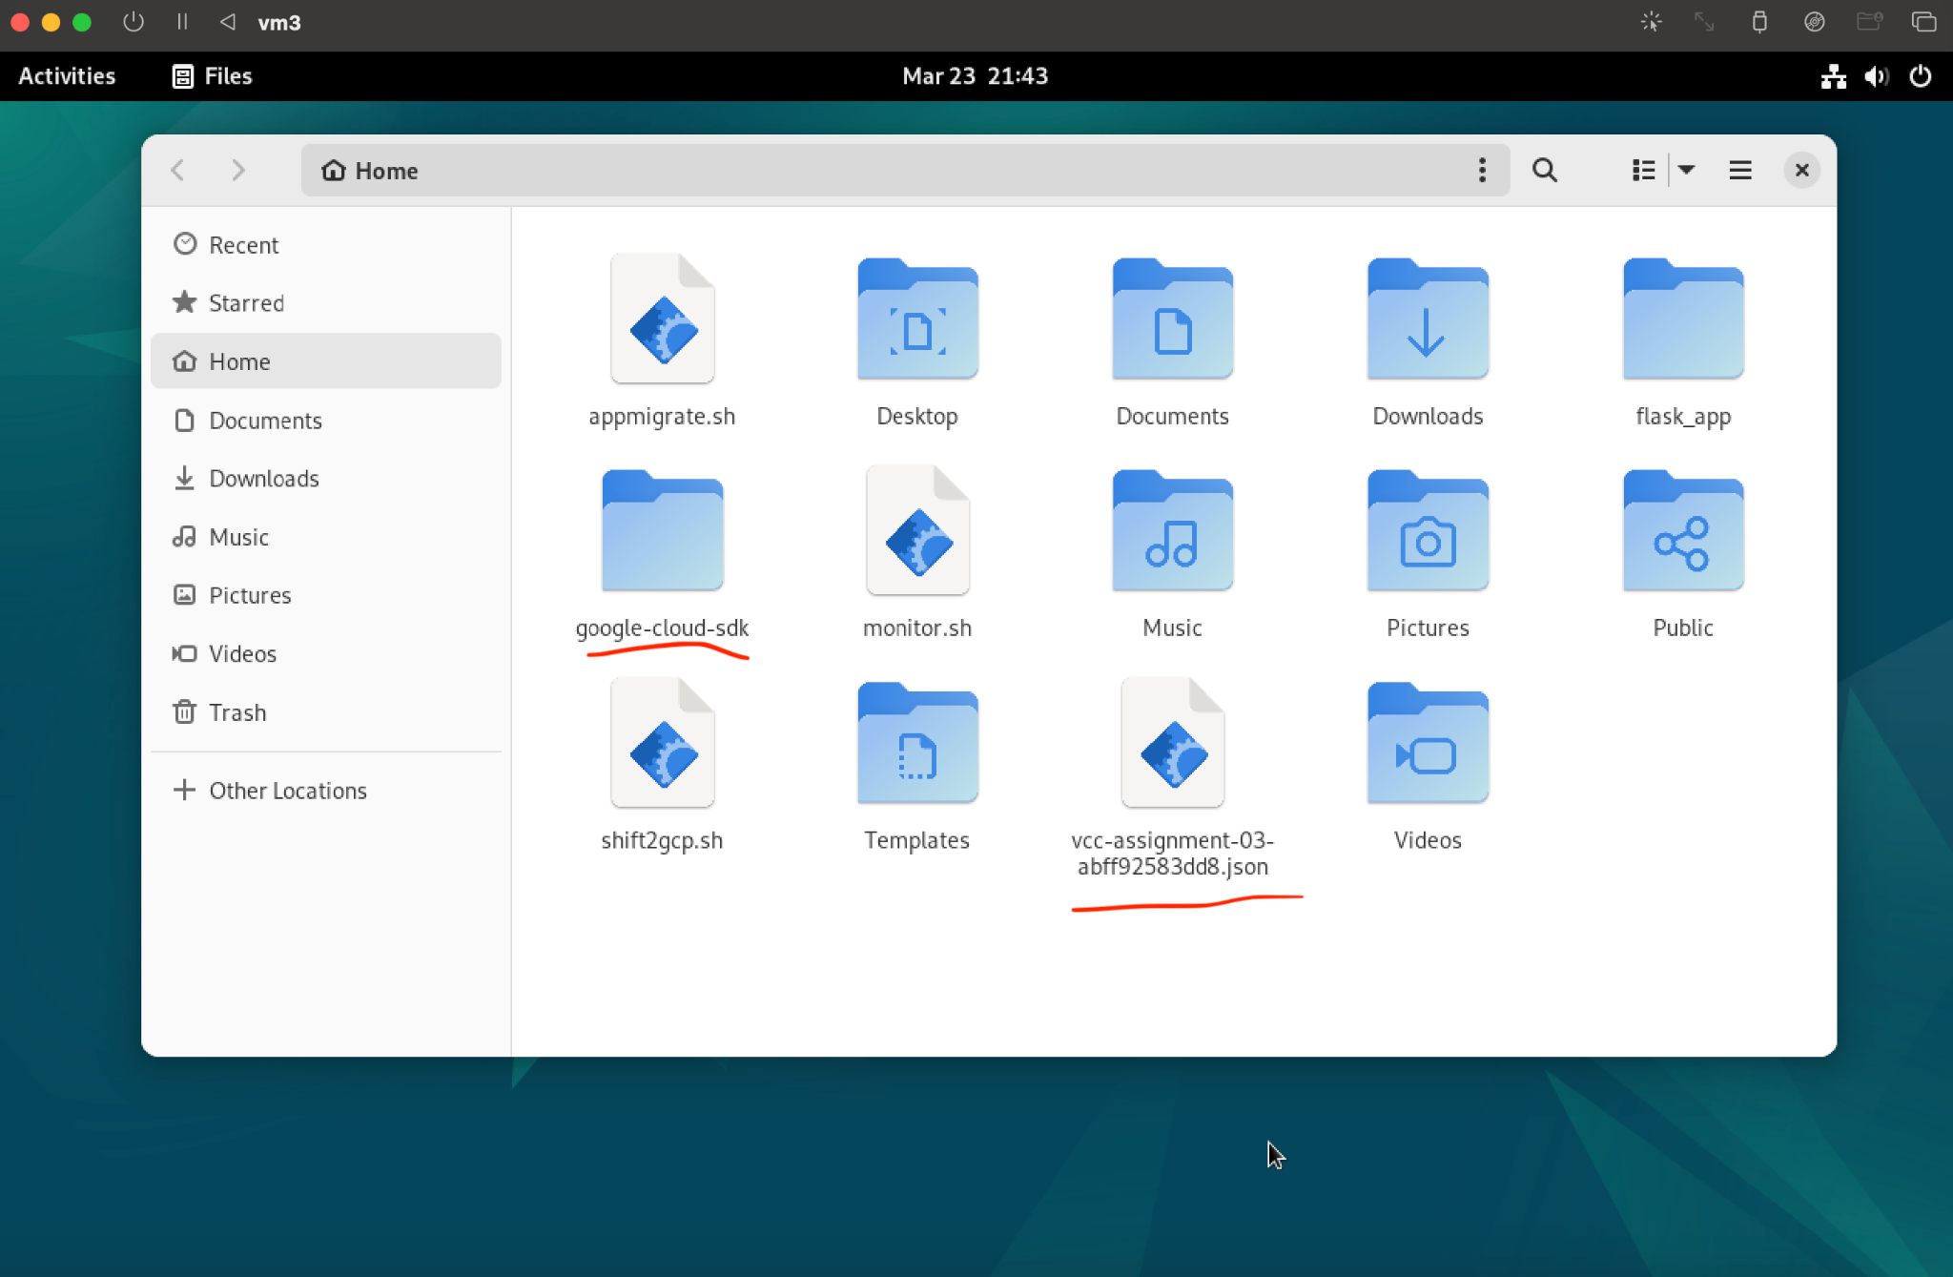

* **Installation of Google SDK (as shown above)**

1. **Deployment of sample application and demonstration**

**-** creation of application **(app.py)**

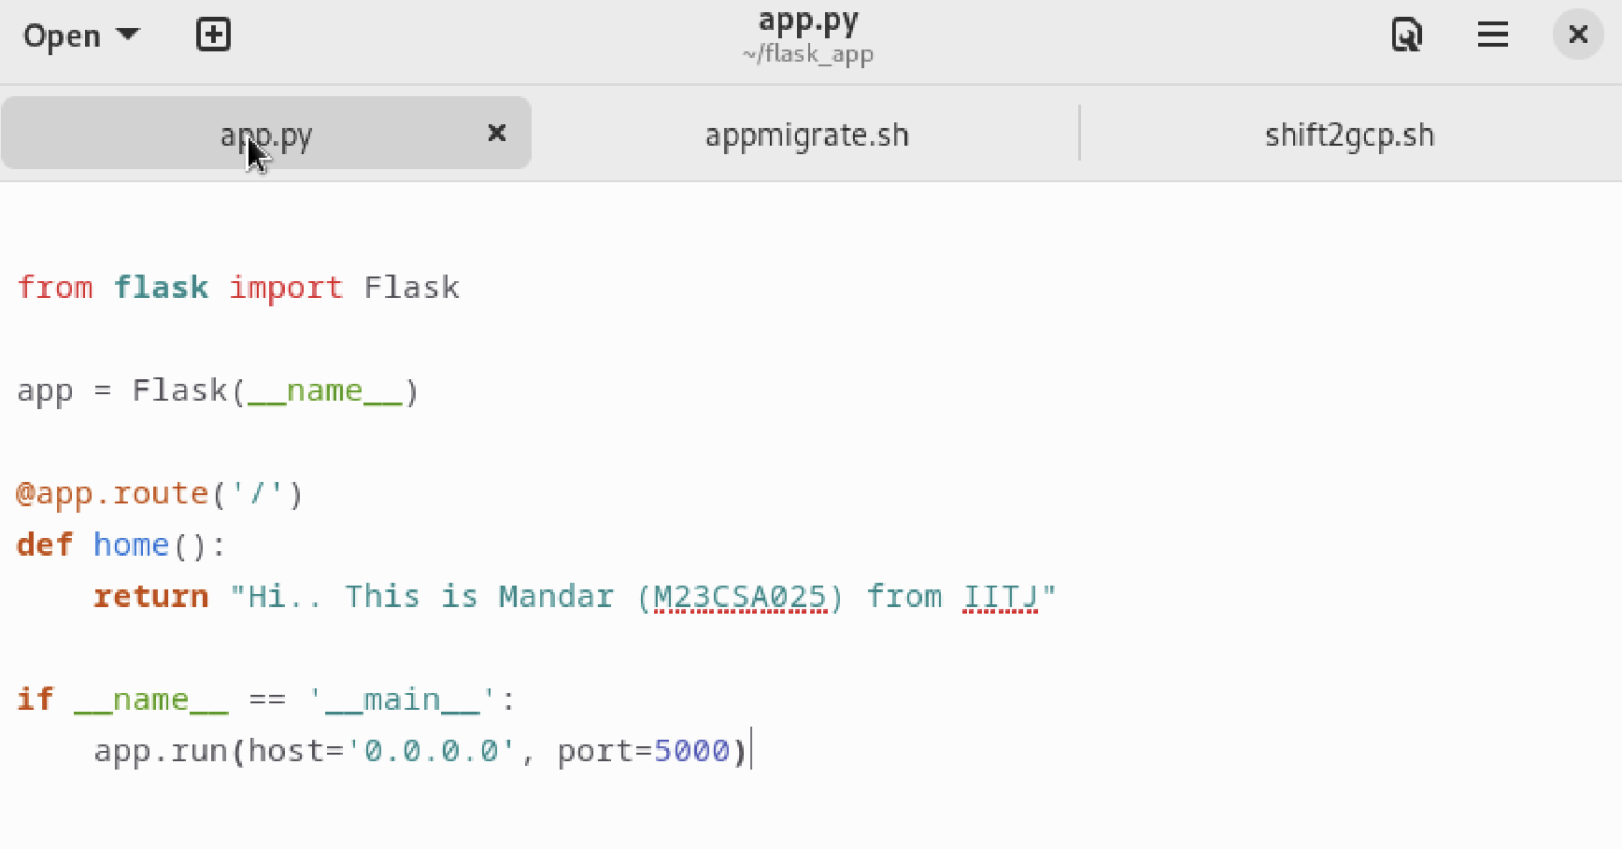

* Loading of Python, flask on vm3
* Creation of application migration code (**appmigrate.sh)**

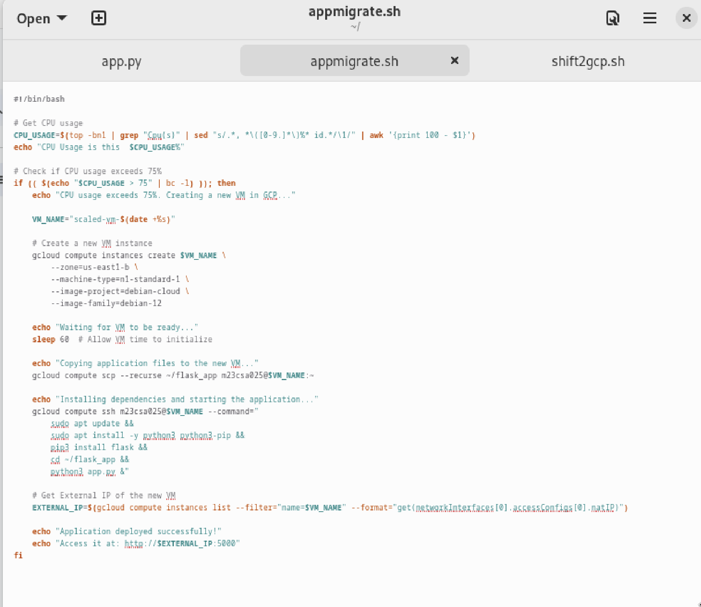

**Execution**

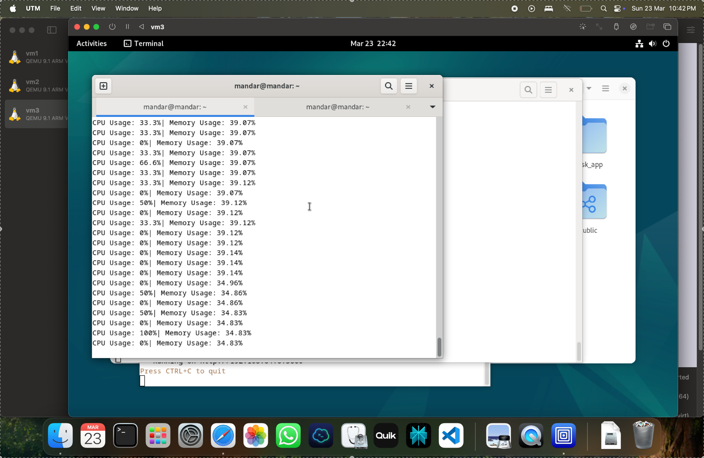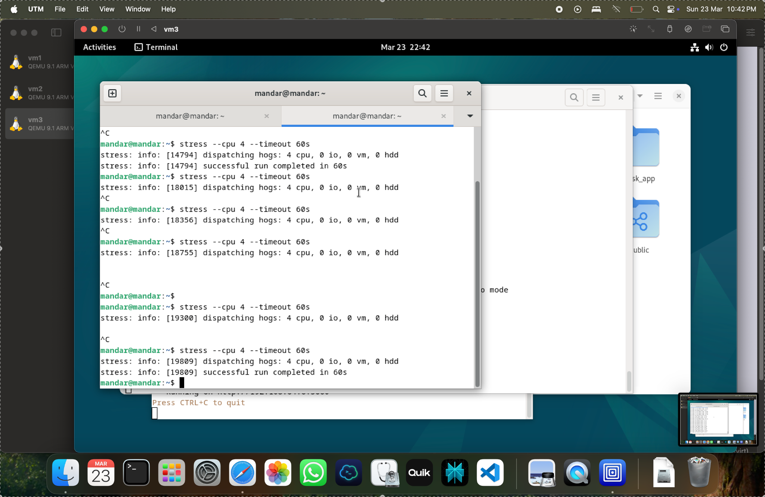

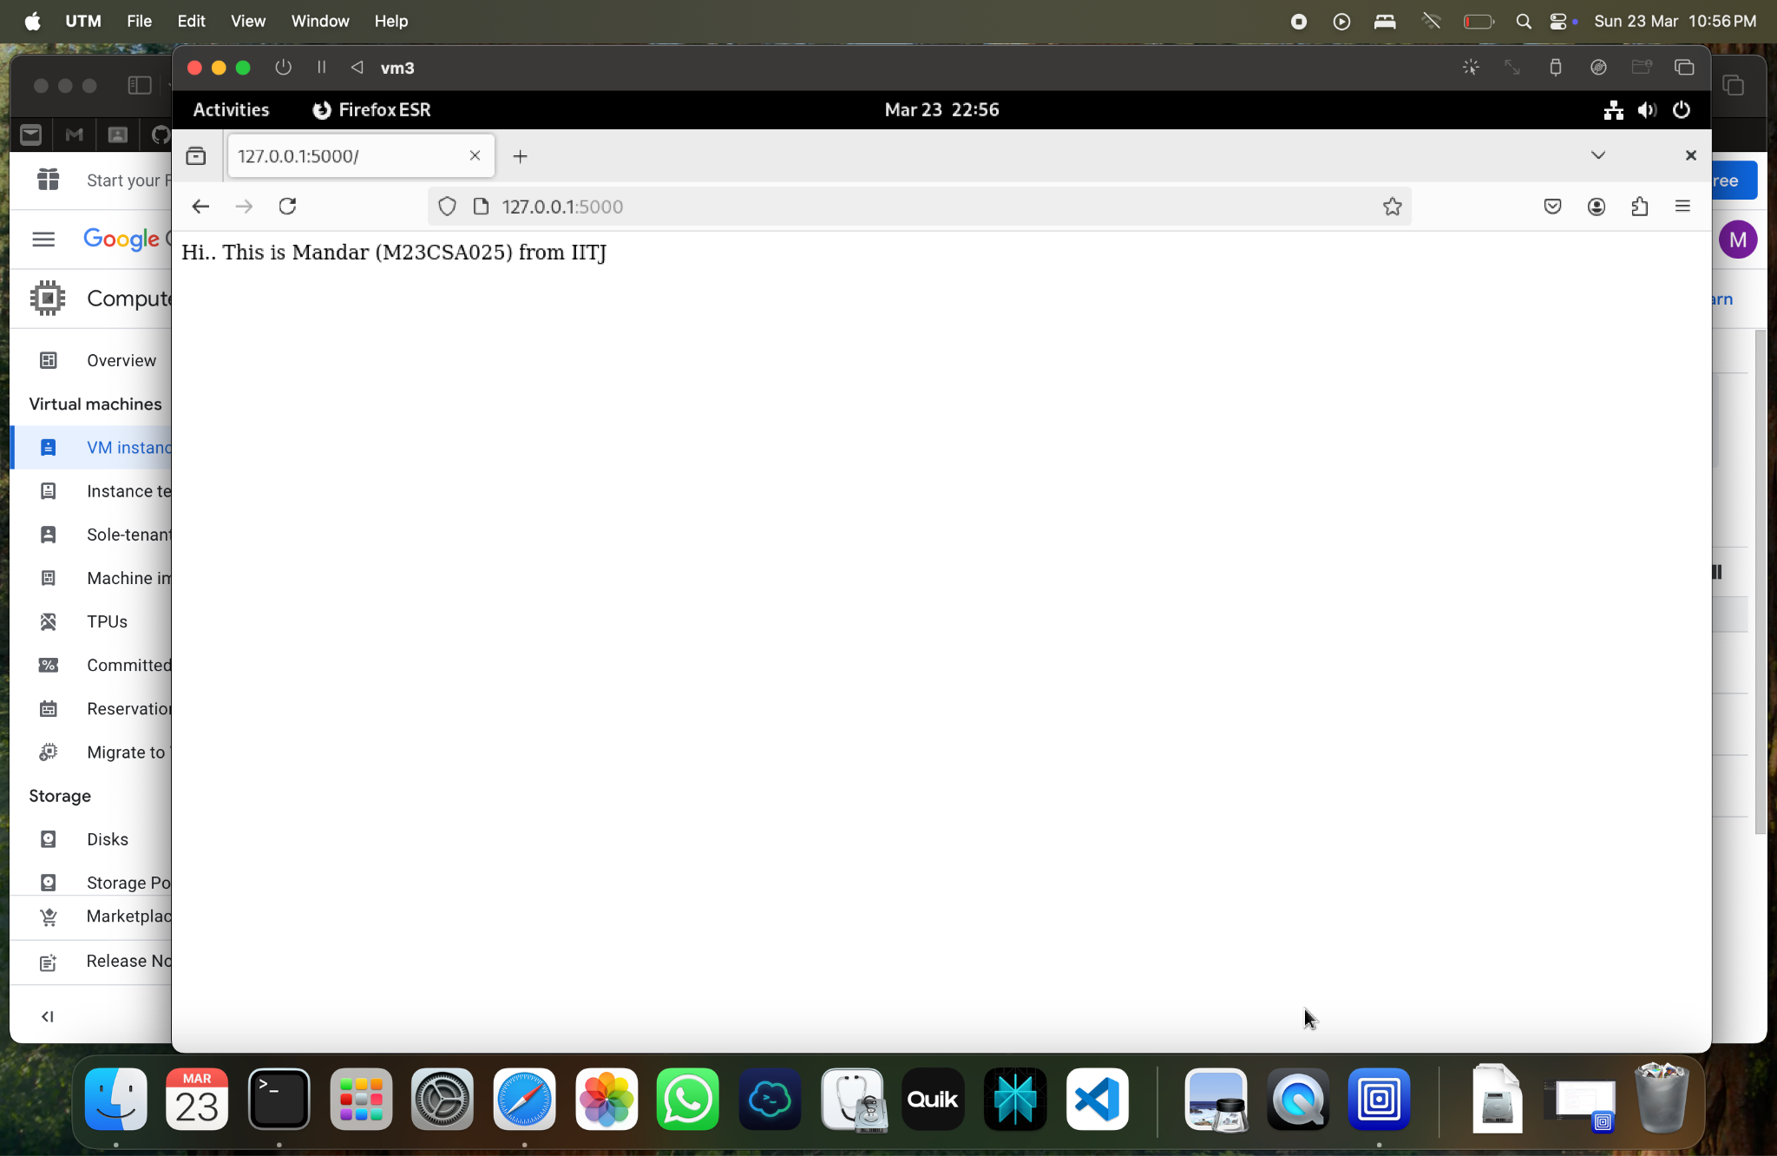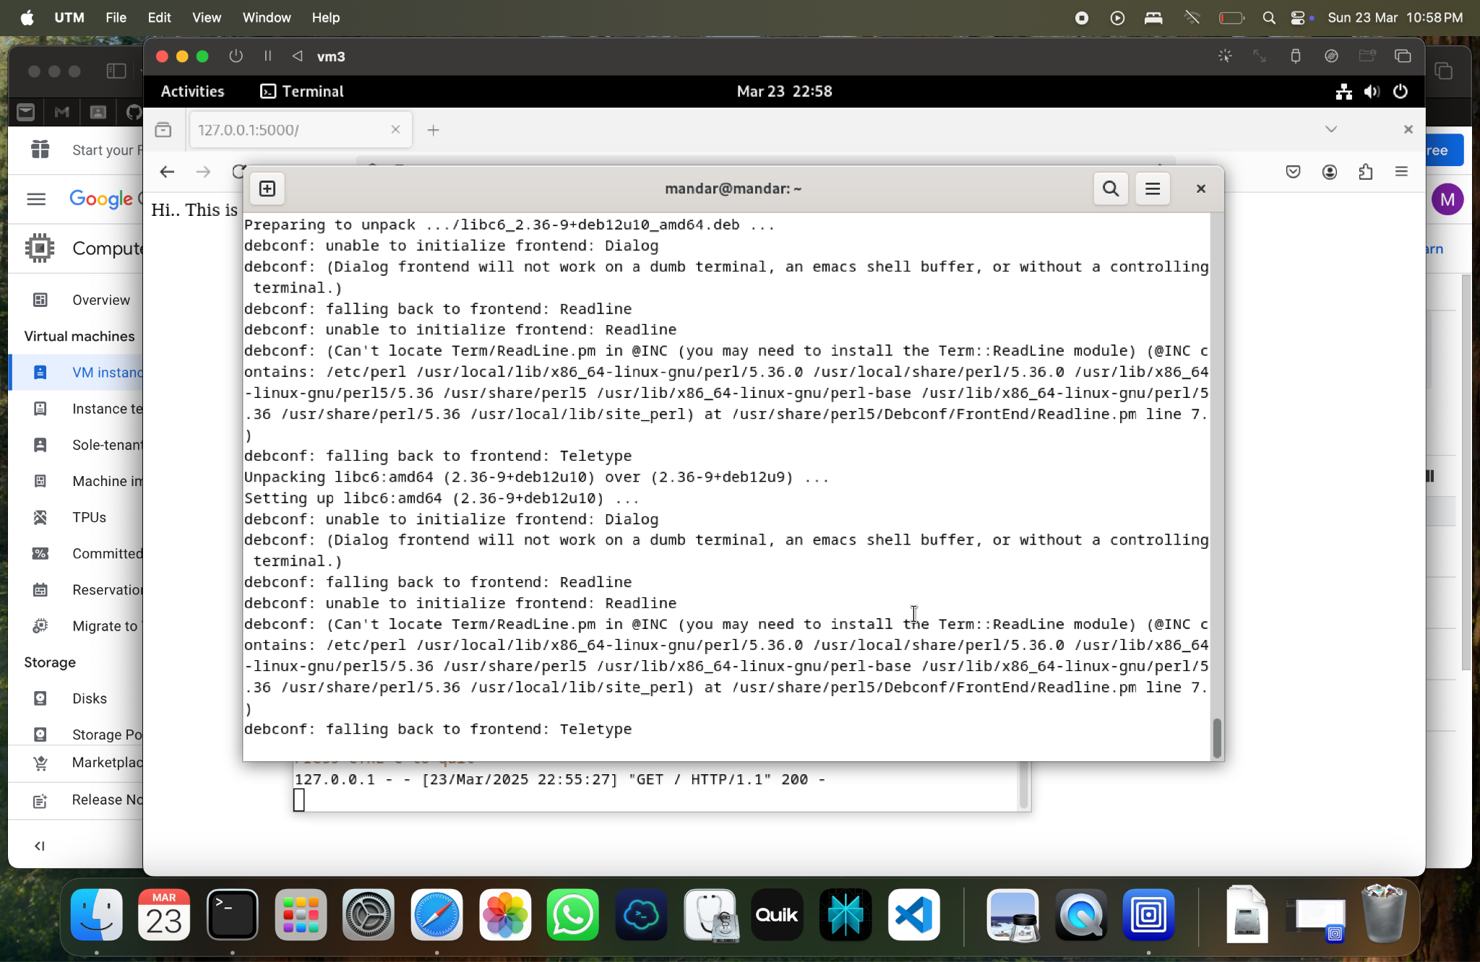

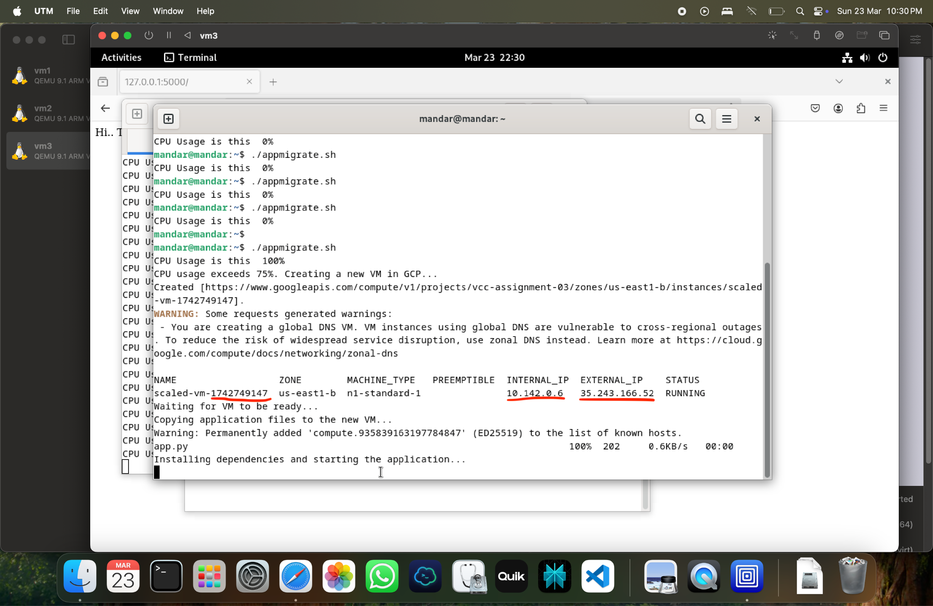

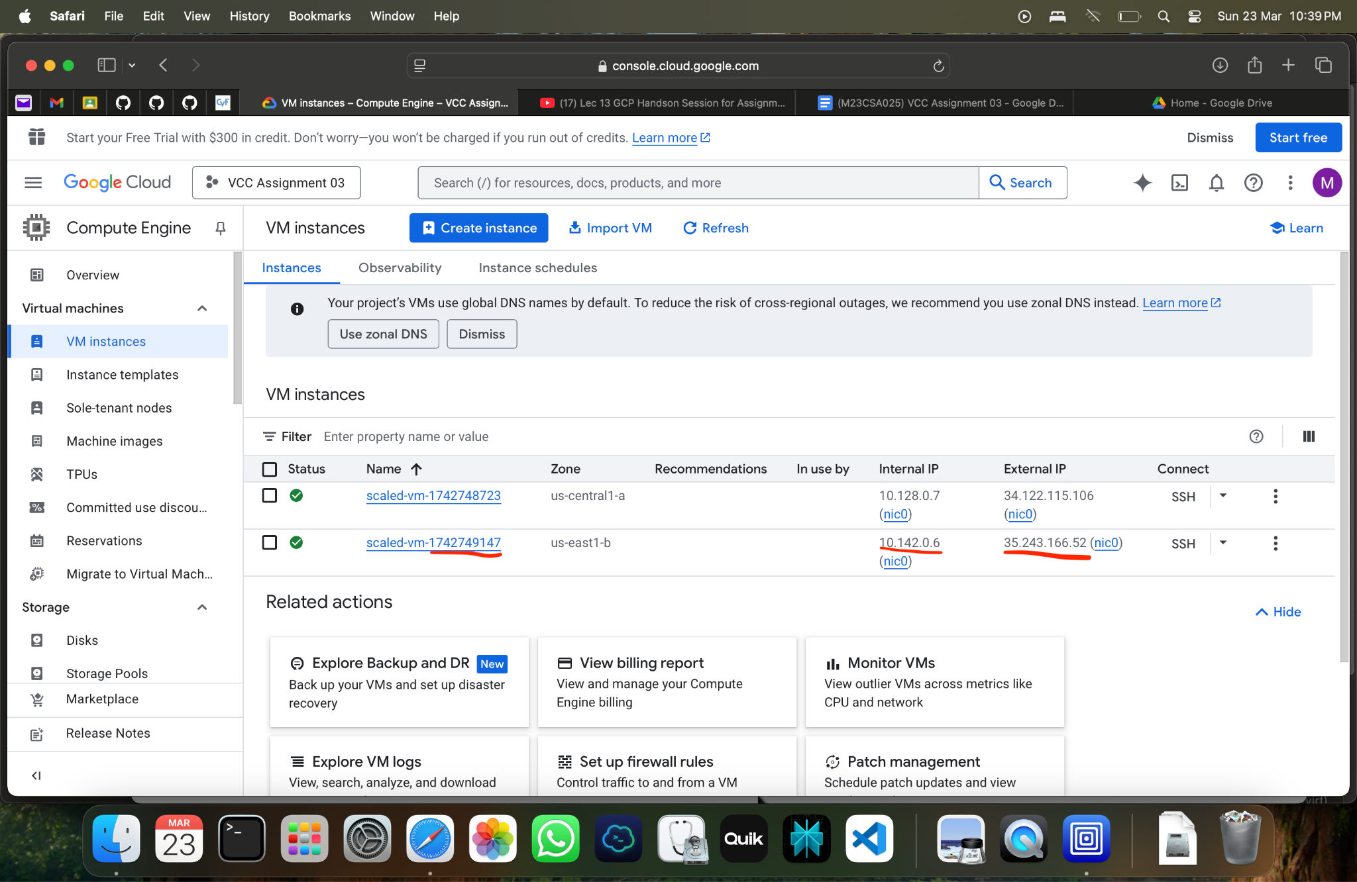

**Architecture Design**

